**Teen shot, killed while riding bicycle in**

**Dorchester**

**By Alexandra Koktsidis and Jan Ransom** Globe Correspondent and Globe Staff, June 11, 2015, 12:14 a.m.

A 16-year-old teen was shot and killed while riding his bicycle on Fuller Street in Dorchester Wednesday evening, officials said, the second shooting of a youth on a bike in the city in the past several weeks.

The unidentified teenager was taken to Boston Medical Center, where he died from his injuries, police said.

At the scene Wednesday night, Commissioner William B. Evans said police are looking for two young males in sweatshirts who fled from the area on foot.

“Everyone should be outraged when a 16-year old on his bike gets shot,” Evans said. “We need the public to step up.

Advertisement



“I can’t say I don’t think it was a random act, but I can’t go into that right now. It’s a terrible tragedy in the streets of Boston.”

Mayor Martin J. Walsh, who joined Evans, said, “We’re doing what we can to get guns off the streets.

. . . However old people are, they shouldn’t be afraid of being shot.”

**Get Today's Headlines in your inbox** Enter Email

[example@email.com](mailto:example@email.com)

**Sign Up**

The day's top stories delivered every morning.

The mayor also said that more opportunities need to be available for young people.

Wednesday’s incident comes after 7-year old Divan Silva was shot on May 24 while riding his bike on Bowdoin Street in Dorchester. He was hit by a bullet in the thigh, but is recovering.

Evans said the killing of the 16-year-old was the 11th homicide in Boston this year. Last year around this time, he said, there were about 24 homicides.

The Rev. Mark Scott, associate pastor at Azusa Christian Community church on Washington Street, said neighbors must pull together.

“It’s my neighborhood. I live in Codman Square and I know the history of the violence between Fuller and Washington streets at a time when it was very bad,” Scott said. “It has gotten much better. There is a community in Codman Square that is resilient and we’re going to need that to get through this.

Advertisement

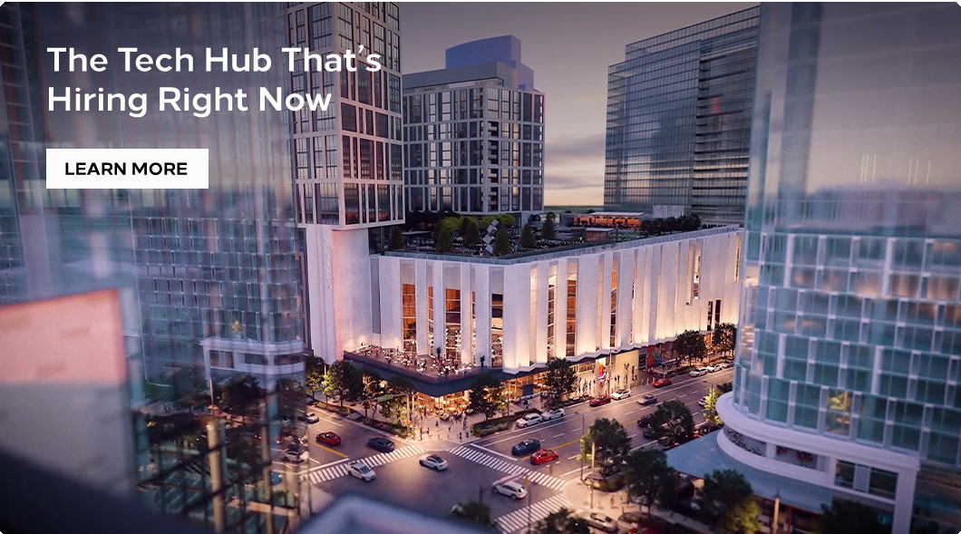

“I would add that the community will heal better if there is justice. Any person with any information at all should please please share.”

The shooting sparked a strong reaction on social media, including from many in the community who appeared to know the victim.

“Told lil cuz I was going to see him when I had a weekend off . . . now I can’t,” one Twitter user wrote.

The public is encouraged to contact Boston police at 800-494-8477 and the homicide unit at 617-343- 4470 with any information.

[Alexandra Koktsidis can be reached at alexandra.koktsidis@globe.com. Jan Ransom can be reached](mailto:AlexandraKoktsidiscanbereachedatalexandra.koktsidis@globe.com.JanRansomcanbereached) at jan.ransom@globe.com. Follow her on Twitter at @Jan_Ransom.

# BOSTON GLOBE VIDEO

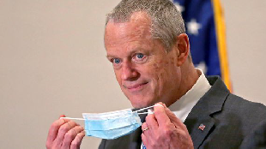

2:23

Baker announces ‘VaxMillions’ lottery program SHARE

Governor Charlie Baker announced residents who are fully vaccinated against COVID-19 will have the chance to win $1 million in a special Lottery sweepstakes. (Photo by Matt Stone/Boston Herald via AP)

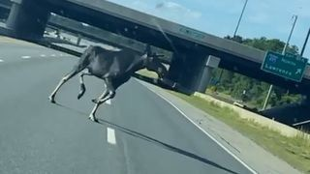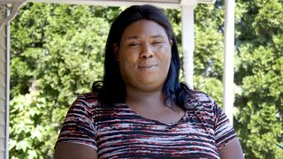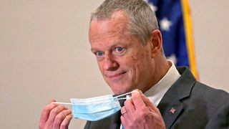

**Baker announces ‘VaxMillions’ lottery program**

**NOW PLAYING**

**Moose spotted on Route 3 in Chelmsford**

**What Black liberation means to me: Athena Vaughn**

# SEE MORE VIDEOS

**MOST POPULAR ON BOSTONGLOBE.COM**

1. Life sciences is poised to be Boston’s dominant industry. Has the area become the Silicon Valley of biotech?
2. Some lawmakers want to ban critical race theory in schools. So, what is it?
3. Is there something wrong with the air in South Portland, Maine?
4. ‘My Name Is Bulger’: Two brothers, one documentary, an only-in-Boston story
5. How Massachusetts communities are celebrating the state’s first official Juneteenth
6. Coolidge Corner Theatre unveils plans for major expansion
7. Message in a bottle, tossed into the sea in Rhode Island, found in Azores
8. A power play? Steam plant owner aims to decarbonize downtown with huge building project
9. A treasure map for an American tyrant
10. The downside of ditching masks: the return of colds, flu



**VIEWS FROM OUR COLUMNISTS**

**YVONNE ABRAHAM**

Energy efficiency is a low-hanging fruit to combat climate change. So why can’t everyone get access to it?

**KEVIN CULLEN**

Bill Bratton on American policing and the challenge facing the Boston Police Department

**THOMAS FARRAGHER**

A salute across the ages to an old squad leader

**SHIRLEY LEUNG**

A working mother’s manifesto: Pandemic provides a once-in-a-generation chance to course correct how we work

**JENEÉ OSTERHELDT**

The pride I carry with me: Karim

**ADRIAN WALKER**

‘The best Boston movie no one’s ever seen’: ‘Blue Hill Avenue’ at 20

**MORE ON GLOBE.COM**

**SPONSORED BY: PHILIP MORRIS INTERNATIONAL**

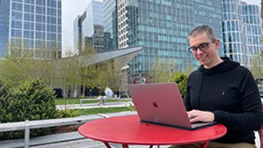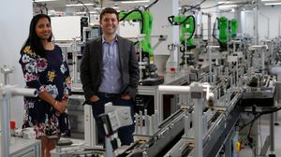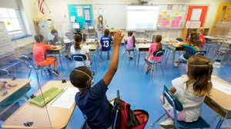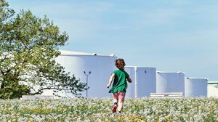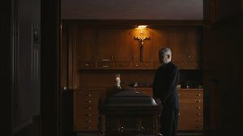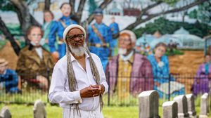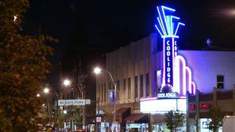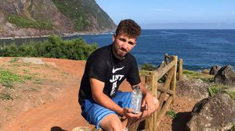

**By going remote, clinical trials are becoming more patient-friendly**

The pandemic pushed research to go virtual. Now, decentralized trials are reaching more people and driving progress.

**INNOVATION ECONOMY**

**Life sciences is poised to be Boston’s dominant industry. Has the area become the Silicon Valley of biotech?**

Since December, you can find six major indications that Boston is the undisputed center of the life sciences industry, a place where ideas and products that change — and save — people’s lives around the world originate.

**THE GREAT DIVIDE**

**Some lawmakers want to ban critical race theory in schools. So, what is it?**

As national debate over race-related curriculums rages on, here is a lesson on the subject and the controversy surrounding it.

**GLOBE MAGAZINE**

**Is there something wrong with the air in South Portland, Maine?**

Residents have lived near more than 100 massive petroleum storage tanks for decades, never really knowing if they’re breathing in dangerous chemicals. Now they’re fighting to find out.

**‘My Name Is Bulger’: Two brothers, one documentary, an only-in- Boston story**

The Discovery+ film offers an unusually intimate view of Whitey and Bill Bulger.

**How Massachusetts communities are celebrating the state’s first official Juneteenth**

For more than a century, Juneteenth was a Texan holiday, then a Southern holiday, commemorating the anniversary of June 19, 1865, when General Gordon Granger of the Union Army told formerly enslaved people in Galveston they were free. Now it will be celebrated for the first time across the Commonwealth as an official state holiday.

**Coolidge Corner Theatre unveils plans for major expansion**

Brookline officials are reviewing a proposed expansion of the landmark Art Deco cinema that will add two new screens — and over 200 seats — as well as a larger lobby and third-floor community space, with a catering kitchen and outdoor roof deck.

**RI NEWS**

**Message in a bottle, tossed into the sea in Rhode Island, found in Azores**

The note was written in 2018 by a 13- year-old who was visiting family in Rhode Island.

**A power play? Steam plant owner aims to decarbonize downtown with huge building project**

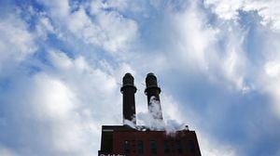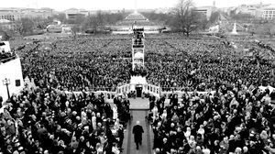

First the partners need to navigate the bureaucracy at the Department of Transportation, which controls the property at the heart of this proposal.

**A treasure map for an American tyrant**

Donald Trump exposed weaknesses that a would-be dictator could exploit to end our democracy. It’s now up to lawmakers, voters, and public officials to prevent that from happening.

**MOST READ IN THIS SECTION**

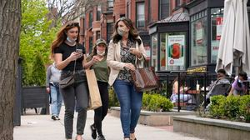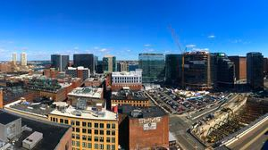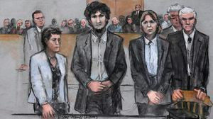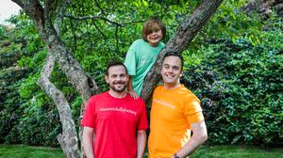

**THE GREAT DIVIDE**

**Some lawmakers want to ban critical race theory in schools. So, what is it?**

**How Massachusetts communities are celebrating the state’s first official Juneteenth**

**GLOBE MAGAZINE**

**Is there something wrong with the air in South Portland, Maine?**

**RI NEWS**

**Message in a bottle, tossed into the sea in Rhode Island, found in Azores**

**The downside of ditching masks: the return of colds, flu**

**With housing at center of Boston mayor’s race, labor and developers are organizing to push candidates**

**Death penalty should be reinstated for Tsarnaev in Boston Marathon bombings case, Biden administration tells Supreme Court**

**A Milton gay couple was harassed anonymously for years. Then a piece of handwriting unraveled the mystery**

**FOLLOW US**

**SUBSCRIBE NOW MY ACCOUNT CONTACT MORE**

Digital Access / Home Delivery / Gift Subscriptions

Log In /

Manage My Account / Customer Service

Help & FAQs / Globe Newsroom / Advertise

Newsletters / View The EPaper /

Order Back Issues / News In Education / Search The Archives / Privacy Policy / Terms Of Service / Terms Of Purchase / Work At Boston Globe Media /

Do Not Sell My Personal Information



**METRO SPORTS BUSINESS & TECH OPINION**

WELCOME, JOHN

**TODAY'S PAPER**

**Summer Fitness Challenge Starts Monday**

Sign up now

©2021 Boston Globe Media Partners, LLC